Learning Journal Unit 8

Godfrey Ouma
University of the People
CS 1101: Programming Fundamentals
Janice Block
August 10, 2023

Learning Journal Unit 8
Input file:

Python program:
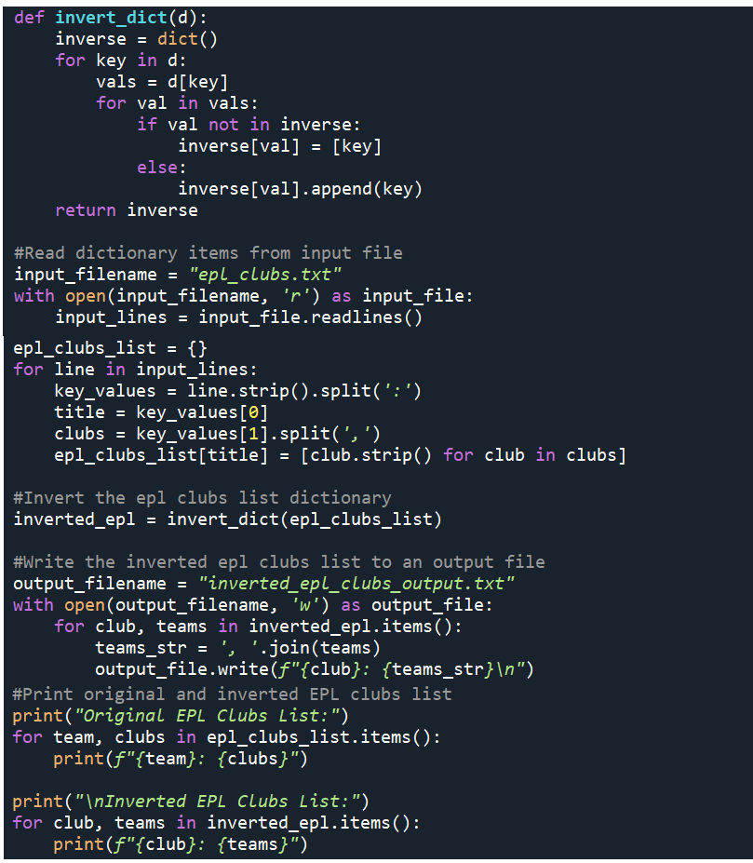
Output:
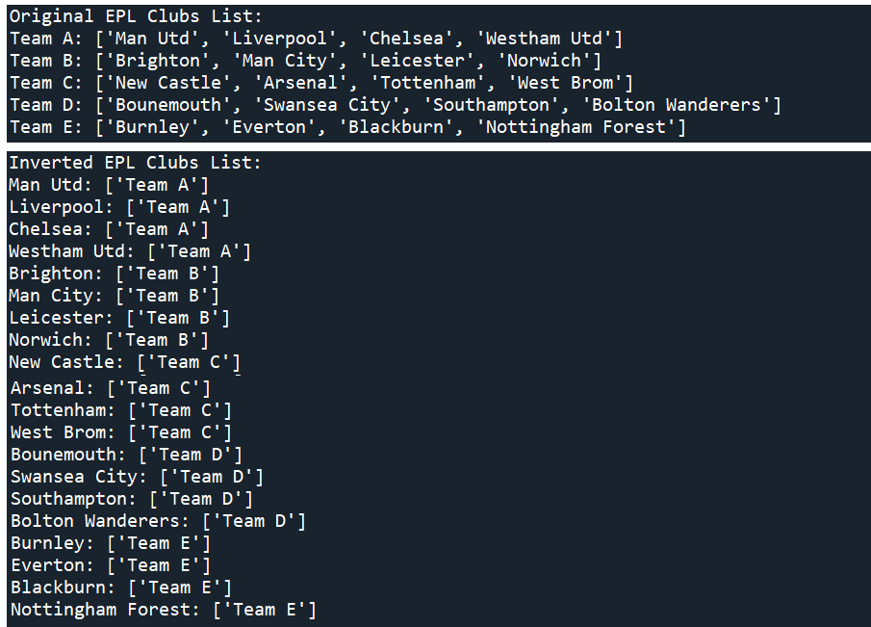
Explanation:
This Python program above performs the following tasks:
1. Defines a function `invert_dict(d)` that inverts a dictionary of lists. It iterates through the input dictionary and creates a new dictionary where the values become keys, and each key is associated with a list of original keys from the input dictionary.
2. Reads dictionary items from an input file named `epl_clubs.txt`, where each line contains a team and a comma-separated list of clubs.
3. Processes the input data and constructs a dictionary `epl_clubs_list` with teams as keys and lists of clubs as values.
4. Applies the `invert_dict` function to the `epl_clubs_list` dictionary, creating a new inverted dictionary named `inverted_epl`.
5. Writes the inverted dictionary `inverted_epl` to an output file named `inverted_epl_clubs_output.txt`, where each line contains a club and a comma-separated list of teams associated with it.
6. Prints the original and inverted EPL clubs lists, displaying the teams and their corresponding clubs from the `epl_clubs_list` and `inverted_epl` dictionaries, respectively.
7. Prints a message indicating that the inverted EPL clubs list has been written to the output file.
The output of the program displays the original and inverted EPL clubs lists. The inversion process ensures that each club is associated with the teams that have that club in their list. The code showcases dictionary manipulation, file I/O operations, and inversion techniques. It provides insights into how dictionaries can be transformed to represent relationships between items in a different way, highlighting the connections between clubs and teams in this specific example.

Reference
Downey, A. (2015). Think Python: How to think like a computer scientist. Green Tree Press.

